**` Medical History form for Botox**

**First Name Last Name Date of Birth (DD/MMM/YYYY)**

____________________________________________________________________________

**BC Care Card Phone Email**

____________________________________________________________________________

**Address Family Doctor**

____________________________________________________________________________

**Significant Medical History**

____________________________________________________________________________

**Current Medications** (Please include over-the-counter medicines and herbal or dietary supplements taken regularly.)

____________________________________________________________________________

____________________________________________________________________________

____________________________________________________________________________

**Allergies**

____________________________________________________________________________

**Smoker** 🞎Yes 🞎No

**History of Cold Sores (Herpes)** 🞎Yes 🞎No

**Currently breastfeeding or pregnant** 🞎Yes 🞎No

**History of keloid scarring** 🞎Yes 🞎No

**Recent intake of Aspirin, Advil, anti-inflammatoris, blood thinners, Vit E, omega 3 supplements** 🞎Yes 🞎No

**Areas you like treated**

🞎Frown lines (20-30 units)

🞎Forehead lines (10-20 units)

🞎Crows feet (24-30 units)

🞎Chin (8-10 units)

🞎Masseter face shaping (50-80 units)

🞎Other _________________________________________

**Botox Diagram**

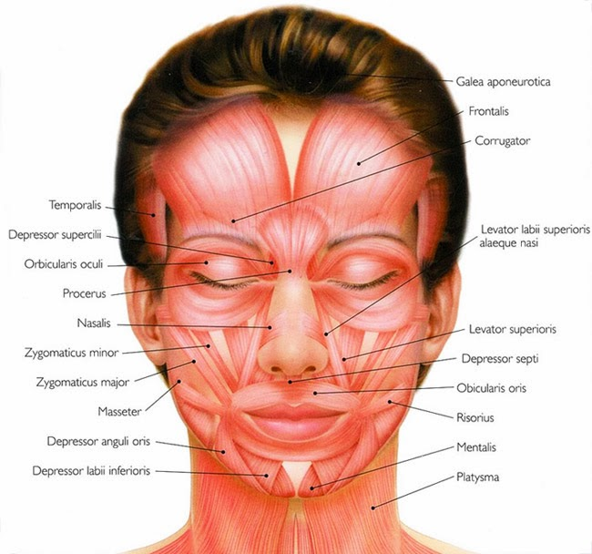

Botox Quote:

Signature :

____________________________________________________________________________